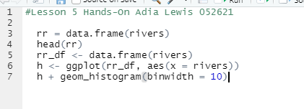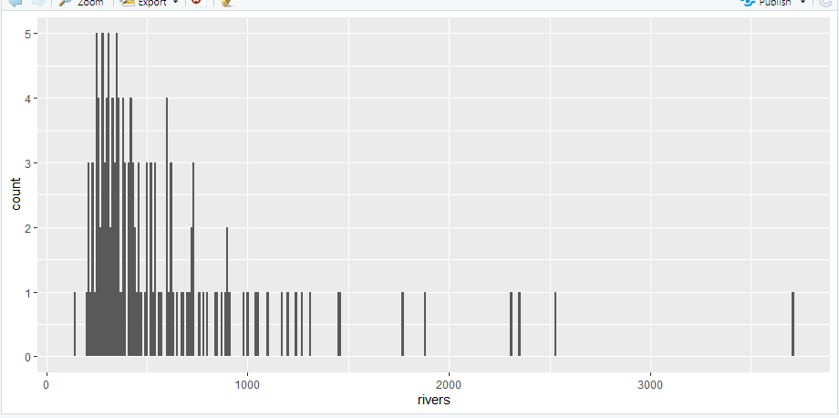

rr = data.frame(rivers)

rr_boxplot <- ggplot(warpbreaks, aes(x="rivers", y = breaks))

rrs_boxplot + geom_boxplot(rr) + xlab("breaks")ggplot(rr, aes(sample = rivers)) + geom_qq()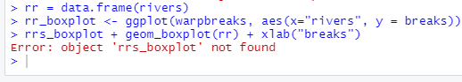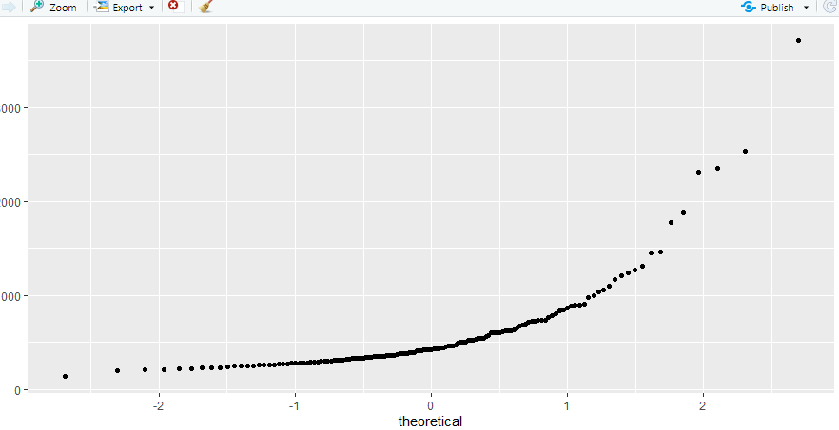

summary(rr)

IQR <- 680 - 310

Outlier_Range <- IQR * 1.5

680 + Outlier_Range

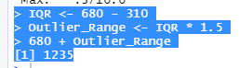

Not a normal distribution